Tatton Wildlife Newsletter – Spring
Spring is a wonderful time to explore the parkland and to witness the changes that are taking place around us. The benefits of getting out and connecting with the natural world are well known and as the days are getting longer and warmer, what better time to immerse yourself in this fantastic season?
Deer
The supplementary deer feeding will stop as the new grass begins to grow. As it has been a mild winter, the deer have maintained good condition, this will give the females a good start in preparation for calving later in the summer. They will now moult into their summer coats; the red deer change to a deeper russet colouration and the fallow a lighter speckled coat.
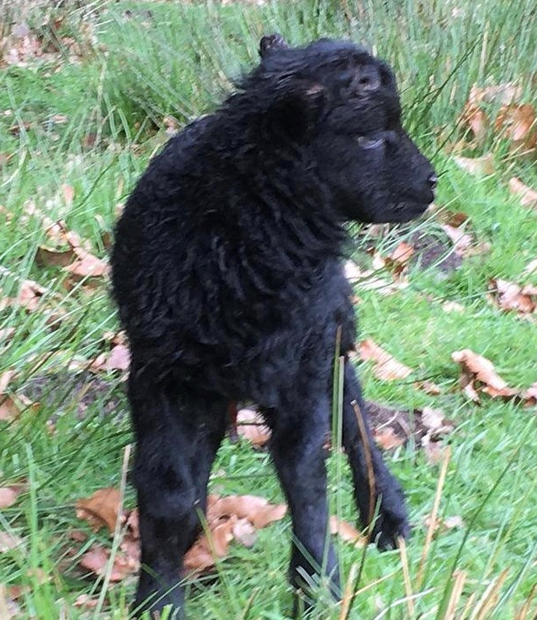
The antlers are shed annually at this time of year, and the new ones begin to grow immediately. The red deer cast first followed by the fallow. The new antlers are delicate and soft to the touch and any knocks to them at this stage may result in a deformed antler later in the year. Deer may be seen rearing up and “boxing” at this time of year to settle any disputes protecting the antlers and preventing damage. They will spend the spring and summer growing them and during this period they are known to be “in velvet”.
Sheep
At the beginning of April, the parkland Hebridean and Soay rare breed sheep will begin lambing. They lamb outside and are left to their own devices which is normal for these hardy breeds. The ewes tend to wander away from the main flock to lamb in a quiet area. Some access restrictions to their fields will be in place at this time of year to prevent any disturbance as lambs can easily be abandoned.
Birds
Spring is the best season to get out and look and listen for birds. Birds are on the move at this time of year, whether it be winter visitors leaving us or summer migrants arriving and heading to their breeding grounds. Now is the time that unusual species are likely to be found. Look out for hobbies hunting over the meres in April or maybe even a passing osprey. The first sand martins arrive back on Tatton Mere at the beginning of March followed by swallows and several warbler species. Wheaters are often seen here in spring and the Mill Pool track is a good place to look for them. Now is the best time to brush up on your bird call skills as they will be in full song, proclaiming rights to a territory or warning a rival male.
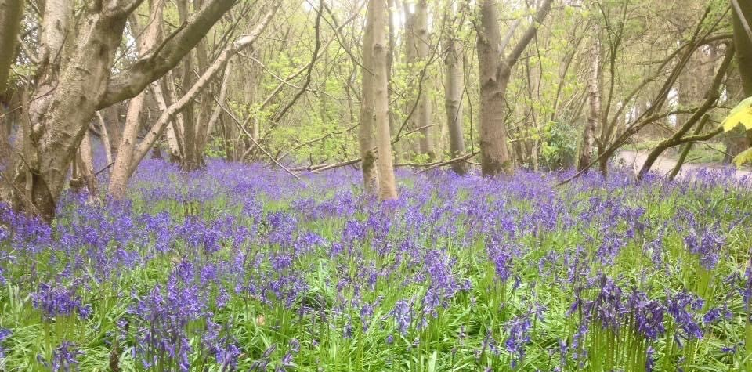
Amphibians
The ponds and woodlands throughout the estate provide excellent habitat for various amphibian species, including the common frog, the common toad, the smooth newt and the great crested newt. From as early as mid-February, frogs, toads and newts become active in our ponds, spawning early to give their young the whole spring and summer to grow rapidly and metamorphise into adulthood before winter. We deliberately leave dead and decaying timber in our woodlands as it provides excellent habitat for amphibians to both hibernate in the winter and to hunt for invertebrate prey in the warmer months.
Common frogs are found in the ponds and slow-moving streams. During spring you will often see clumps of frogspawn just below the surface of the water. Common toads prefer deeper water in lakes and ponds. They lay strings of eggs rather than clumps. Smooth newts are also found in our ponds. Great crested newts are considerably larger than smooth newts, measuring up to 15cm long with an orange belly, but both species often occur together, as they do at Tatton.
Compiled by Tatton’s Ranger Team

